**Musical lighting microcontroller firmware installation manual**

What if you are new to STM32 microcontroller programming?   
What if you have never install any firmware on microcontrollers?   
Which wires to connect, which button to press? Calm down, read below and you will easily feel as experienced engineer.

1. First, you will need simple interface converter USB-COM. You are welcome to find the one you like in the store you prefer. The keyword for search is *FTDI*.

For example: [most popular](https://ru.aliexpress.com/item/Free-Shipping-1pcs-FT232RL-FTDI-USB-3-3V-5-5V-to-TTL-Serial-Adapter-Module/32481520135.html?spm=a2g0v.search0104.3.6.61c3265ctYaLbm&ws_ab_test=searchweb0_0,searchweb201602_5_10065_10068_5730212_319_5729712_317_10696_10924_453) или [the cheapest](https://ru.aliexpress.com/item/FT232RL-FTDI-USB-3-3-5-5-ttl-forarduin/32883190719.html?spm=a2g0v.search0104.3.1.4a93265cXPcaRO&ws_ab_test=searchweb0_0%2Csearchweb201602_5_10065_10068_319_5730213_317_10696_10924_453_10084_454_10083_10618_10920_10921_10922_1)

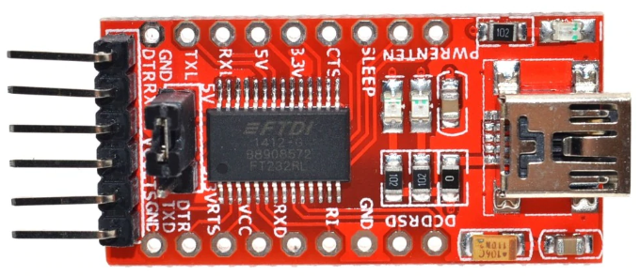

So, let us suppose you already have a board with STM32 controller and an interface converter.

1. Assembling the circuit

You will need four wires; colors are presented as in picture.

1st red, power +5V провод красный питание +5V

2nd brown, common

3rd yellow, informational, from A9 on controller (output) to RX on converter (input).

4th green, informational from TX on converter (output) to A10 on controller (input).

Connection sequence:

Rearrange the jumper on the convertor board to 3.3V, 5V contact remains free;

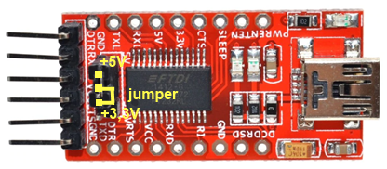

Connect the freed 5V contact with the 5V contact of the controller board contact via the red wire;

Connect common outputs of converter (GND) and controller (G) via the brown wire;

Yellow wire connects A9 on controller (output) with RX on converter (input);

The green one connects TX on converter (output) with A10 on controller (input).

Such configuration allows you to avoid death of microcontroller in case of accidental applying 5V to the output ports of the converter if you forget to rearrange the jumper.

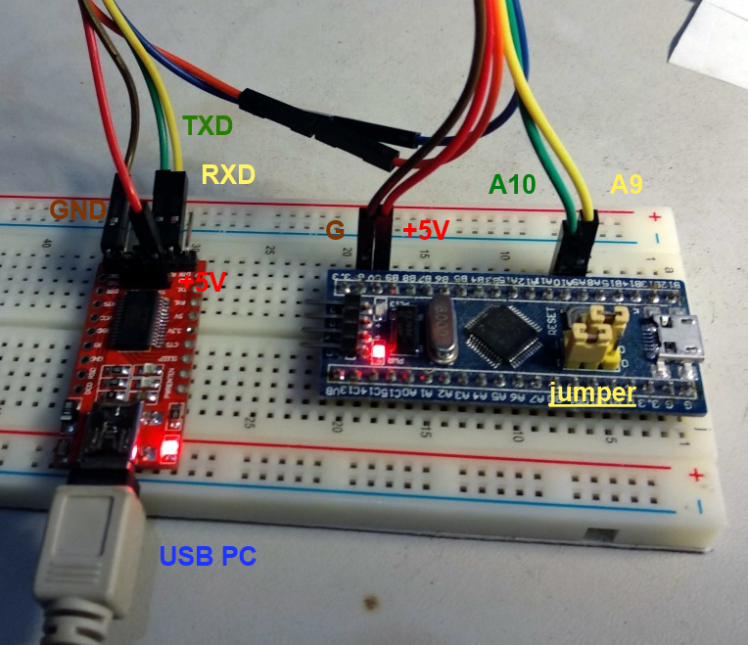

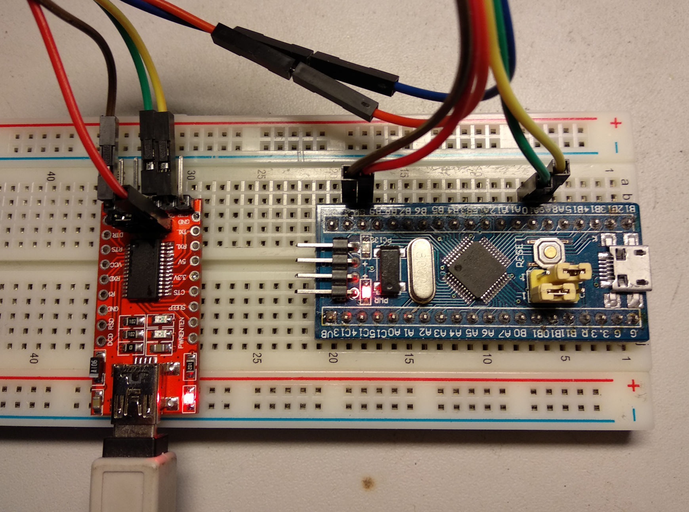

The only hardware thing left is to connect converter to PC via the micro USB cable. However, before you need to download as well as the programmer software.

1. You are welcome to download the firmware from one of the links below:

Google Drive: <https://drive.google.com/open?id=1g5eqV_OeZVYaQT4km8bjpoutT9iPgOI0>

Facebook group: <https://www.facebook.com/groups/336136297134996/>

4. Programming

Download the programmer software from the microcontrollers’ manufacturer [website](https://www.st.com/en/development-tools/flasher-stm32.html).

Execute the program.

|  |  |
| --- | --- |
|  |  |
| Select port, to which you connected USB-COM converter and Baud Rate 115200. (how to find out the port name see below in the attachment)  Press -> Next | Press -> Next |

|  |  |
| --- | --- |
|  |  |
| Press -> Next | Select “**Download to device**”. Search and ~~destroy~~ open downloaded firmware file **MC.HEX**. |

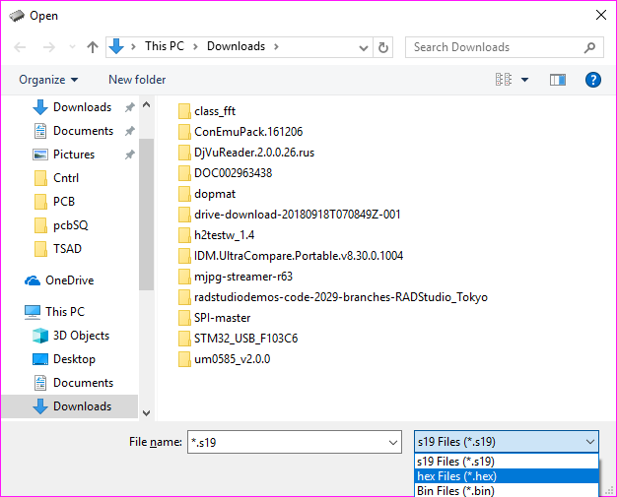

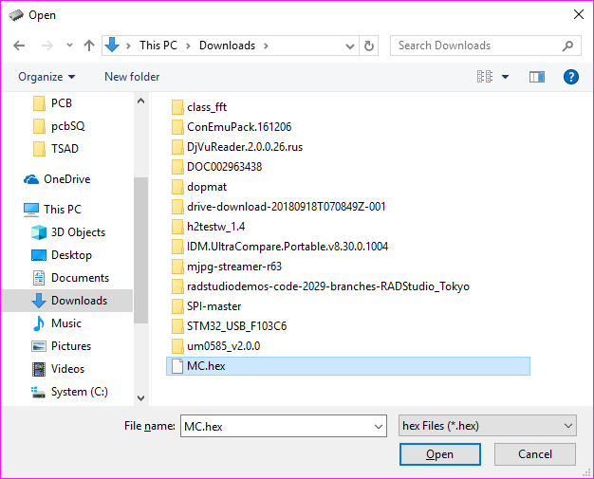

Press-> Open

Then

Press -> Next

Wait until the end of download

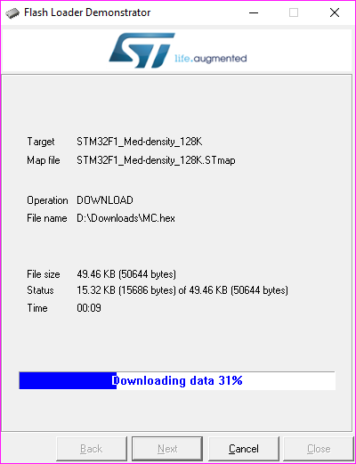

Press -> Close **Congrats, you now have musical lighting controller with installed firmware!**

**Attachment:** How to find out the COM port name

I will show you how to do this on Windows operating system; it will be easy to find the same for other systems in Google.

First, press on the start button, then type *devmgmt.msc* and press Enter.

|  |  |
| --- | --- |
|  |  |
| **Select Ports (COM & LPT)** |  |

Here will be the port you needed, in my case it is **USB Serial Port,** my **USB-COM** converter. If you have more than one COM port in the list, you will probably easily figure out, which one is right.

**Good luck!**